Easy part:
- A car, travelling at a constant speed of 30 m/s along a straight road, passes a police car parked at the side of the road. At the instant the speeding car passes the police car, the police car to move with a constant acceleration in the same direction as the speeding car. What is the speed of the police car at the instant it overtakes the other car?
(A). 45 (B). 30 (C) 60 (D) 75 (E) 100

- Two blocks are in contact on a frictionless table. A horizontal force is applied to one block as shown. If m1 = 2kg, m2 = 1kg, and F = 3N, find the force of contact between the two blocks.
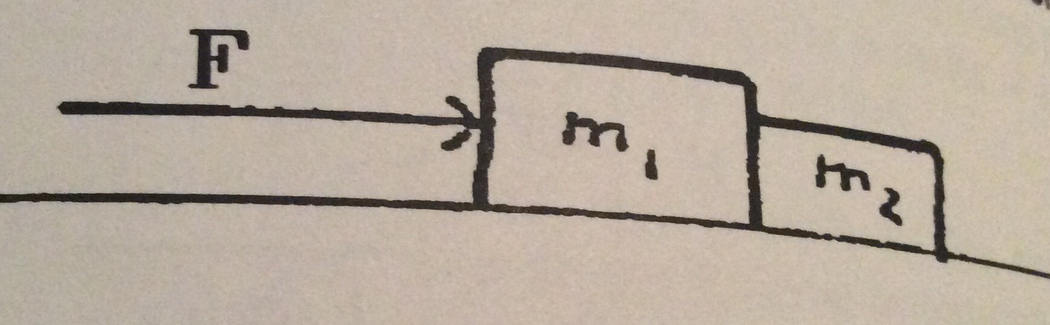

(A) 1 (B). 2 (C) 3 (D) 6 (E) 9

- This symbol represents an airplane as seen from the rear : ┴, showing level wings, body, and vertical tail. Tipped to the left it represents the same plane seen from rear, but banked to make a left-hand turn at constant speed and altitude. In witch of the following diagrams can the vector shown represent the net force acting on the vehicle?
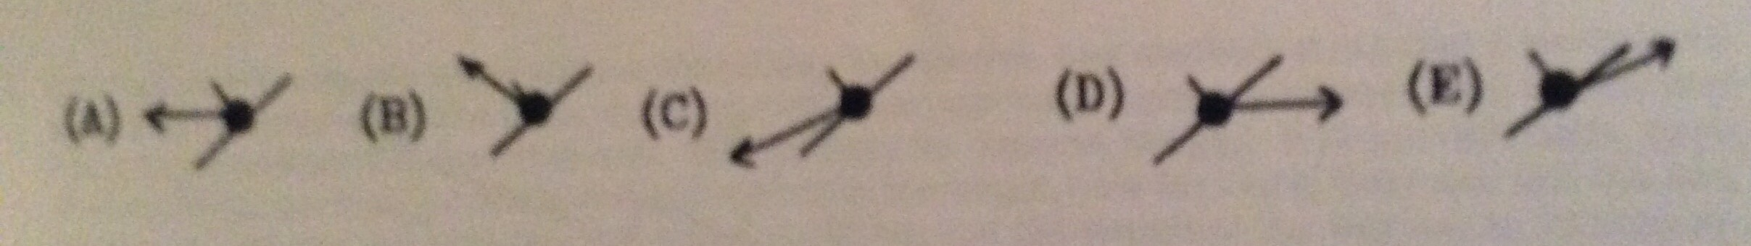

Medium:
- The two planets of Zim and Zot are both spherical and composed of identical uniform material. Zim has twice the diameter of Zot. The Zotians find that to join in the space race, their vehicles need an escape velocity of 20 turtles(a unit of speed on both planets-turtles go fast). What escape velocity must the Zimmians achieve?(Answer in turtles.)
- . 10 (B). 14 (C) 20 (D) 28 (E) 40

- A large truck has enough gears that it can develop constant power over a wide range of speed. It also has a combination of frictional drag and air resistance that remains constant and amounts to 5% of the vehicle weight over a similar speed range. If the truck can drive up a 3% grade(3 meter up for every 100 meters measured along the sloping road surface) at 15km/h under full power, what speed can it attain coming down the same hill?
- 15 (B) 30 (C) 60 (D) 120 (E)no limit

- A body of mass 6 kg and density 450kg/m3 is dropped from rest at a height 7.5 m into a lake. Calculate
(a) the speed of body just before entering the lake,
(b) the acceleration of the body while it is in the lake,
(c) the maximum depth to which the body sinks before returning to float on the surface.

Hard part:
- Two car A and B, are moving with speed of m/s along two roads witch has an angle of 60° between them. When A is 48m away from the intercept point , B is 24 m away from the intercept point. When the distance between A and B are smallest? How far?

8. As shown in the graph, neglect all the friction, find out the acceleration of c in terms of Ma , Mb, and Mc(mass of the three blocks).
